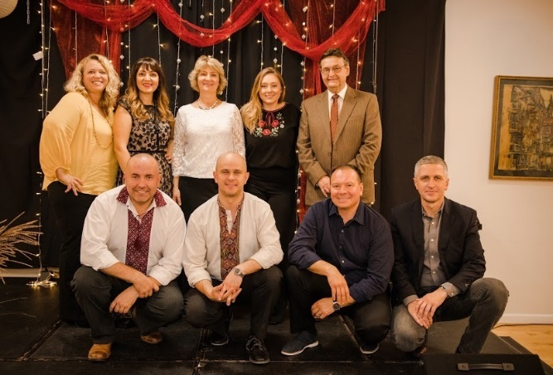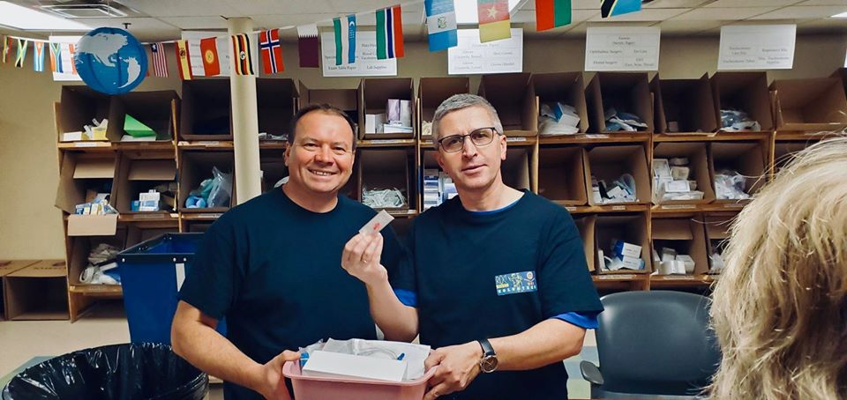

OUR MISSION: HELP UKRAINE

We strive to help held Ukrainian soldiers in need. War struck Ukraine in 2014 after the Euro Maidan Protests. The war on anti-terrorism has been raging on in Eastern Ukraine ever since. Many young men are risking their lives to protect their country. We work on providing them with supplies, humanitarian aid, and rehabilitation equipment. We want to help our soldiers in any way possible and all the help we can get is much appreciated.

ABOUT US

We are a nonprofit organization based in Rochester, New York. Our teams is made up of local volunteers of all ages. We strive to help Ukrainian soldiers and other Ukrainians in need during their difficult time in war. We package and ship supplies, humanitarian aid, and rehabilitation equipment. We also host and take part in many events in order to promote awareness and raise money. Stay updated with our events so you don’t miss out! Any volunteering, donations, or help big or small would be much appreciated!